Proceedings of the 43st National Conference on Mechanical Engineering of CSME: Guidelines for Manuscript Preparation

Author Name¹*, Author Name²
¹First Author’s English Affiliation
²Second Author’s English Affiliation
（NSTC XXX-XXXX-X-XXX-XXX）
＊Email: Corresponding author’s email address

Abstract
The 43st National Conference on Mechanical Engineering of CSME will be hosted by the National Chung Cheng University. It will be held in Chiayi County on December 4 and 5, 2026. To assist participants in preparing their manuscripts for the conference proceedings, this Word template is provided.

Keywords: A list of 2-4 keywords should be included right beneath the abstract.
1. Introduction
The length of each paper should 4~6 pages. Manuscripts submitted should strictly follow the format of this template. Only manuscripts in PDF format with no page numbers are acceptable and manuscripts should be submitted via the official website of the 43st National Conference of CSME, https://csme2026.conf.tw/. The size of the PDF file should be less than 10 MB.

2. Format
2.1 Paper Format
2.1.1 Margin Setting
The paper size is A4 (21 cm by 29.7 cm) with the following margins: upper 3 cm, lower 3 cm, left 2 cm, and right 2 cm. These margin settings should be followed under all circumstances.
2.1.2 Font Setting
The acceptable fonts are Times New Roman and Symbol. The title of the article should be in 14-point boldface type. Capitalize the first letter of nouns, pronouns, verbs, adjectives, and adverbs; do not capitalize articles, coordinate conjunctions, or prepositions (unless the title begins with such a word). Authors’ names and affiliations are to be centered beneath the title and in 12-point non-boldface type. Subtitles should be in 11-point and boldface. Type your main text in 10-point. All paragraphs should be indented by 0.9 cm.

2.2 Keywords
A list of 2-4 keywords should be included right beneath the abstract.

3. Figures, Tables and Equations
Figures and tables can be either placed at the end of the paper as demonstrated in this template, or inserted within the running text.
3.1 Figures and Tables
Captions of figures and tables should be in 10-point Times New Roman. The alignment of the caption can be either centered or justified, depending on the width of the figure.
3.2 Equations
Equations should be centered aligned and numbered.

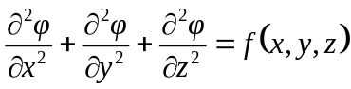 (1)

4. References
List and number all bibliographical references at the end of your paper. When referenced in the text, enclose the citation number in square brackets. Formats are given below for your reference for journal paper [1], book [2], conference paper [3], thesis[4], and webpage [5].

5. Conclusions
We are looking forward to seeing you at the conference. If you have any problem or question in preparing or submitting your manuscript, please feel free to contact us via the following e-mail address: csme2026@ccu.edu.tw.

6. Acknowledgements
This work is funded by the National Science and Technology Council under grant NSTC-000-0000-E-000-MY3.

7. References
- S. L. Chiu and T. H. Lin, “Breakup of Compound Liquid Jets under Periodic Excitation at Small Core-to-Shell Mass Ratios,” Journal of the Chinese Institute of Engineers, Vol. 31, No. 1, pp. 21-28, 2008.
- H. S. Yan, Creative Design of Mechanical Devices, Springer, Singapore, pp. 166-188 (1998).
- S. Vechet, J. Krejsa and K. S. Chen, “AGVs mission control support in smart factories by decision networks”, Proceedings of the 2020 19th International Conference on Mechatronics - Mechatronika (ME 2020), Prague, Czech Republic (2020).
- 鄧予安, "銅與環氧樹脂界面受循環負載下之疲勞裂紋成長", 國立成功大學機械工程學系碩士論文, 台灣 (2003).
- https://csme2026.conf.tw/

8. Figures and Tables
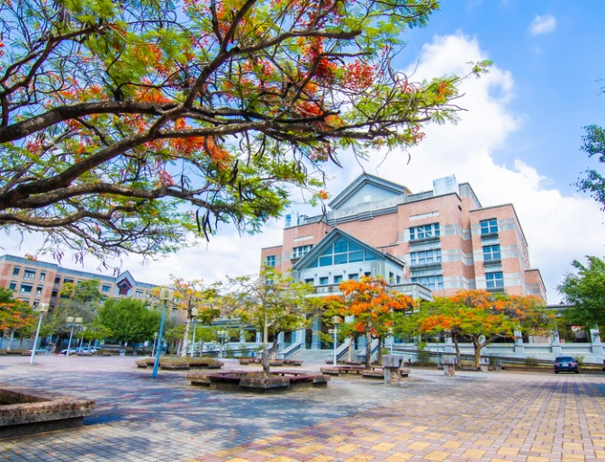
Fig. 1 The 43st National Conference on Mechanical Engineering of CSME will be held in Chiayi County on December 4 and 5, 2026.

Table 1 Important dates for the 43st National Conference on Mechanical Engineering of CSME.
Paper Submission Deadline | 2026.09.20
Notification of Acceptance | 2026.09.21 - 2026.09.30
Final Paper Submission Deadline | 2026.10.31
Online Payment Deadline | 2026.10.31

